# Paul Singleton_Module 6.2_CSD310_6-25-24

Screenshot of Script Results: (source C:/csd/csd-310/module-6/db_init_2022.sql;)

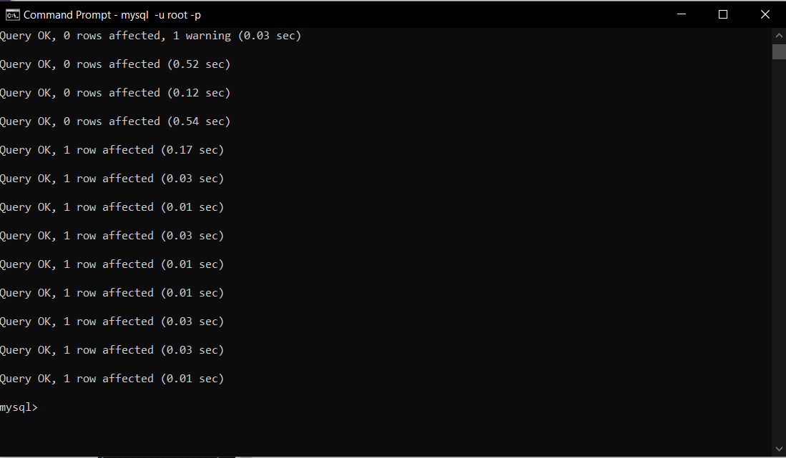

Screenshot of: (SHOW tables;)

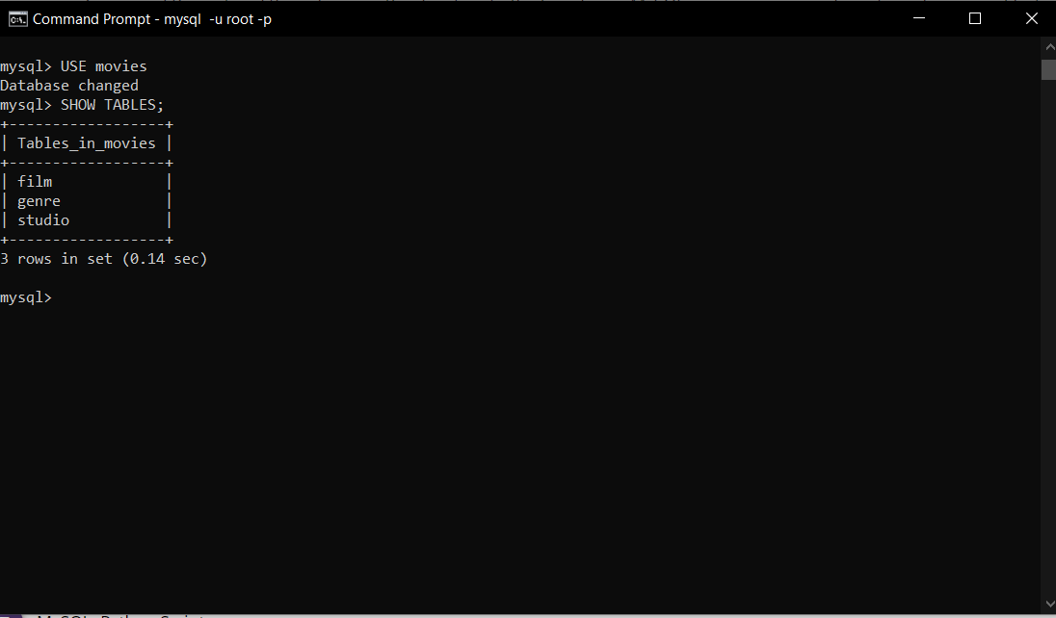

Screenshot of Python Script Results: (cd C:\csd\csd-310\module-6 > python mysql_test.py)

